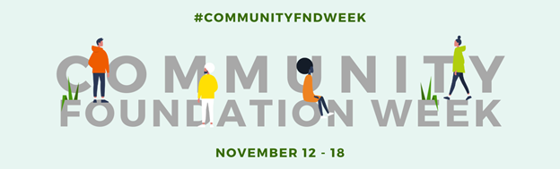

SAMPLE SOCIAL CONTENT FOR COMMUNITY FOUNDATION WEEK
Social media is a great way to build awareness for Community Foundation Week and elevate your organization’s impact. Below is content you can use before and during Community Foundation Week to engage your audiences. Here are a few tips to consider:
- Photos and videos improve engagement on social media, especially content that reflects your organization’s work and community impact.
- Community Foundation Week graphics are available to use in your posts. Visit http://cof.org/cfweek to download digital assets.
- Be sure to use #CommunityFNDWeek in your posts and help amplify the collective voice of community foundations.
Questions? Contact the Council on Foundations for more information: cofcommunications@cof.org.
Promotional Social Content to Use Before November 12:
- Join the Council on Foundations from 11/12-11/18 to celebrate Community Foundation Week. This campaign celebrates the vital role local philanthropy plays in empowering positive social and economic community change. To learn more, visit http://cof.org/cfweek.
- Next week is Community Foundation Week! Created in 1989 by former president George H.W. Bush, this week recognizes the important work of community foundations and their collaborative and innovative approach to working with the public, private, and nonprofit sectors. Learn more: [insert link to your website detailing how you are acknowledging/celebrating the event]
Promotional Social Content to Use Between November 12-18:
Facebook and LinkedIn
- We’re excited to celebrate Community Foundation Week from Nov. 12-18. We know that we can only succeed because people like you care about improving your community, both now and into the future. We are so grateful to everyone who has contributed to our success, and we look forward to growing our work together!
- Happy Community Foundation Week! To celebrate all the great work we can do thanks to your support, here are some of our favorite pictures from the last year. Comment and let us know which ones are your favorites! [include up to 4 photos]
- We are excited to join the national network of more than 750 community foundations celebrating Community Foundation Week. We’re focused on issues affecting the [XXXX] region and provide support to more than [insert number of nonprofits] nonprofits through our grantmaking, special initiatives, and civic leadership. Learn more at [link].
- [Community Foundation Name] is just one example of a community foundation creating social change in local communities. This #CommunityFNDWeek we wanted to share what other community foundations are doing as well and celebrate the success of the entire field. Check out [Tag another Community Foundation you have worked with].

Twitter
The official hashtag for Community Foundation Week is #CommunityFNDWeek, so include in your tweets. If you are tweeting on a specific topic, use the relevant hashtags to gain more visibility for your tweet. For example, if you are tweeting on education, including #education can help more people see your tweet.
- To celebrate #CommunityFNDWeek, we’re sharing out some of our favorite photos from the past year. Let us know which one you like best! [include up to 4 photos]
- Throughout this #CommunityFNDWeek, we’re highlighting some of the areas we’re working on. Check out our work on [program area]! [add link]
- Do you love our community as much as we do? This #CommunityFNDWeek, contact our charitable giving team at XXXX to chat about how you can work with us to make it better.
- Care about #[insert topic area(s)]? So do we! Get more information on our work here [topic-specific link] and join us in celebrating #CommunityFNDWeek.
- #CommunityFNDWeek isn’t just about us! What do you do to make a difference in [Community Name]? We’d love to celebrate all you do to advance [Community Name].
- This year we provided $X in the form of Y grants to over Z organizations in [Community Name]. Help us celebrate #CommunityFNDWeek by donating so we can exceed these numbers next year! Learn more here [insert link].

