SAMPLE SOCIAL POSTS FOR COMMUNITY FOUNDATION WEEK
Regardless of what social networking site you’re posting to, we recommend using photos, particularly those of people impacted by the work your foundation is doing. Photos and videos perform particularly well on social media. If you have troubles finding unique photos of the work, we have provided several graphics below for your use.
Facebook and LinkedIn
- Happy Community Foundation Week! To celebrate all the great work we can do thanks to your support, here are some of our favorite pictures from the last year. Comment and let us know which ones are your favorites! [include up to 4 photos]
- This week is Community Foundation Week. We know that we can only succeed because people like you care about improving your community, both now and into the future. We are so grateful to everyone who has contributed to our success, and we look forward to growing our work together!
- Happy Community Foundation Week! You can see some of the work your donations help support in our video of XXXX participating in XXXX at [link].

- We are excited to join the national network of over 1000 community foundations celebrating Community Foundation Week. We’re focused on issues affecting the XXXX region, and provide support to more than [insert XXX nonprofits through our grantmaking, special initiatives, and civic leadership. Learn more at [link].

- Today kicks off #COMMUNITYFNDWEEK across the US. Today through November 15, Community Foundation Week recognizes the work of community foundations across the country. Join us by sharing how [Community Foundation Name] has helped your neighborhood!

- Thanks to our donors for enabling [Community Foundation Name] to positively impact the community! #CommunityFNDWeek celebrates our work, but we couldn’t do it without you! [Consider tagging certain levels of donors]

- [Community Foundation Name] is just one example of a community foundation creating social change in local communities. This #CommunityFNDWeek we wanted to share what other community foundations are doing as well and celebrate success of the entire field. Check out [Tag another Community Foundation you have worked with].

Twitter
The official hashtag for Community Foundation Week is #CommunityFNDWeek, so use that with all your tweets. If you are tweeting on a specific topic, use appropriate hashtags for that as well to gain more visibility for your tweet. For example, if you are tweeting on education, including #education can help more people see your tweet.
- To celebrate #CommunityFNDWeek, we’re sharing out some of our favorite photos from the past year. Let us know which one you like best! [include up to 4 photos]

- Throughout this #CommunityFNDWeek, we’re highlighting some of the areas we’re working on. Check out our work on [program area]! [link]

- Do you love our community as much as we do? This #CommunityFNDWeek, contact our charitable giving team at XXXX to chat about how you can work with us to make it better.

- Care about #[topic]? So do we! Get more information on our work here [topic-specific link], and join us in celebrating #CommunityFNDWeek

- #CommunityFNDWeek isn’t just about us! What do you do to make a difference in [Community Name]? We’d love to celebrate all you do to advance [Community Name].

- This year we provided $X in the form of Z grants to over Y organizations in [Community Name]. Help us celebrate #CommunityFNDWeek by donating so we can exceed these numbers next year! Learn more here [insert link].

SOCIAL MEDIA BANNER GRAPHICS
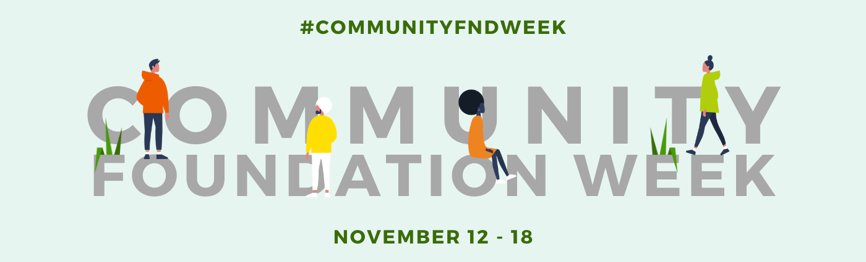
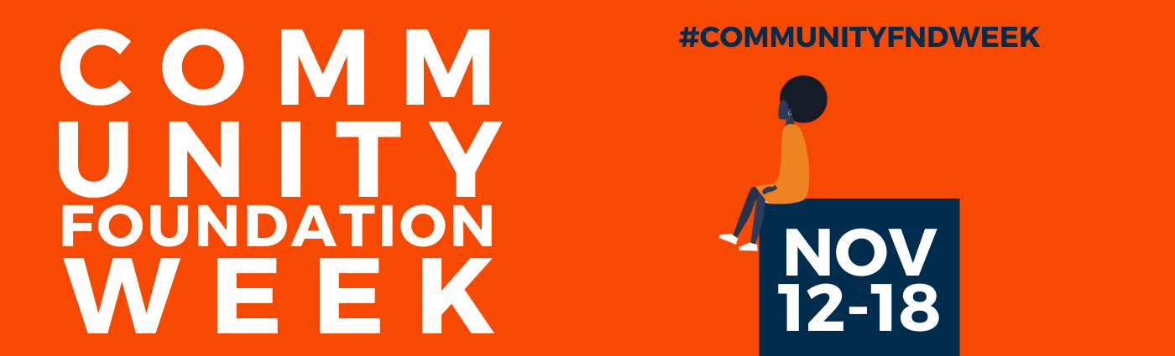
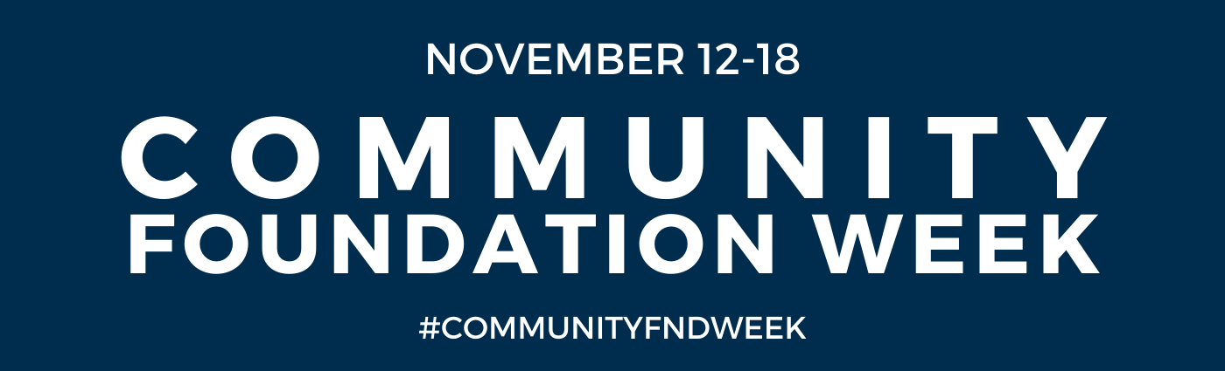
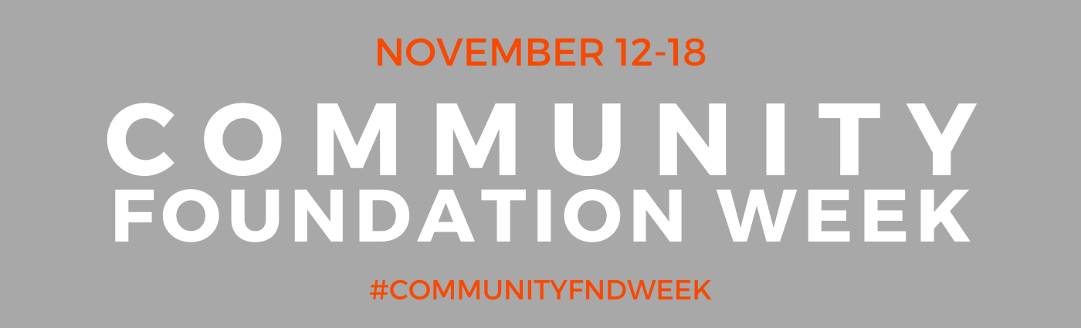
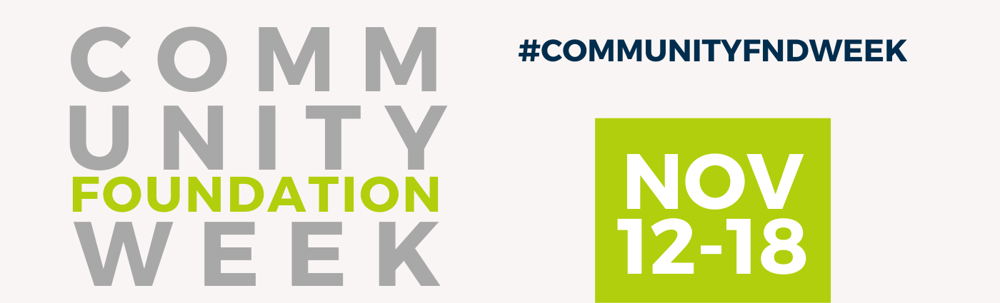
TWITTER/ LINKEDIN POST
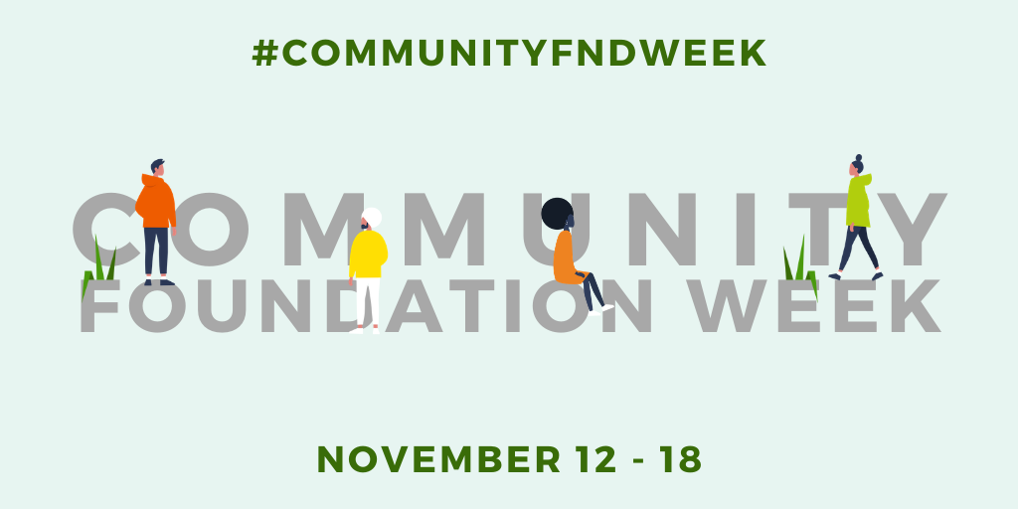
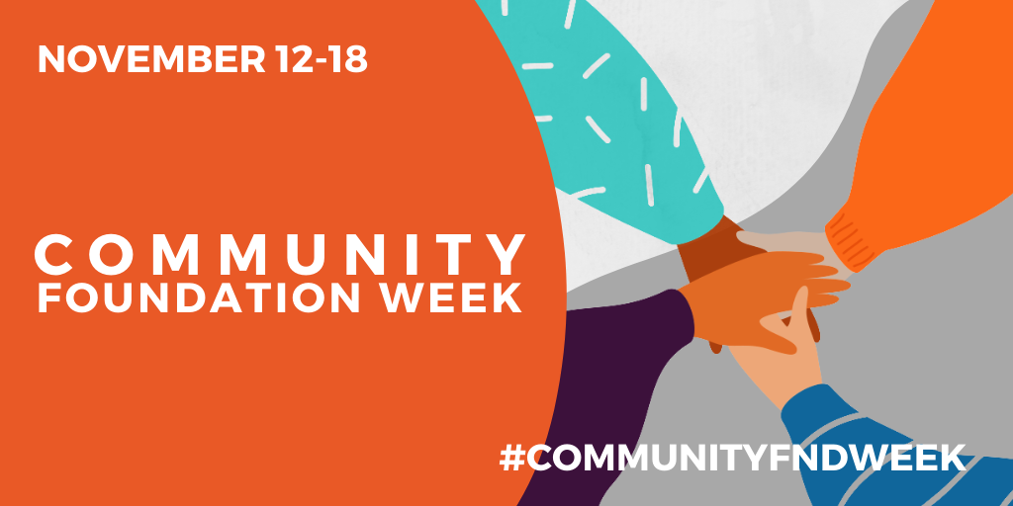
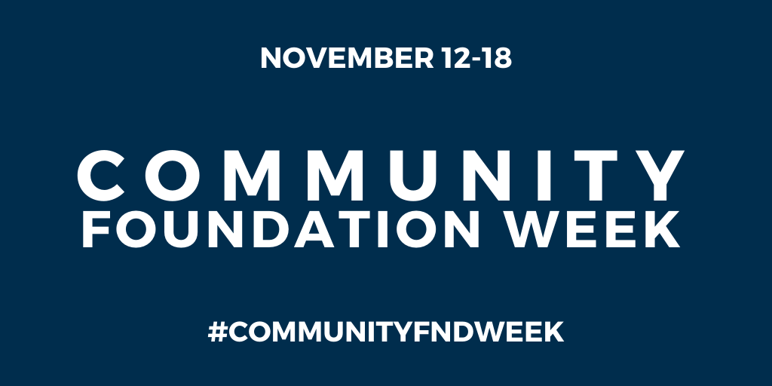
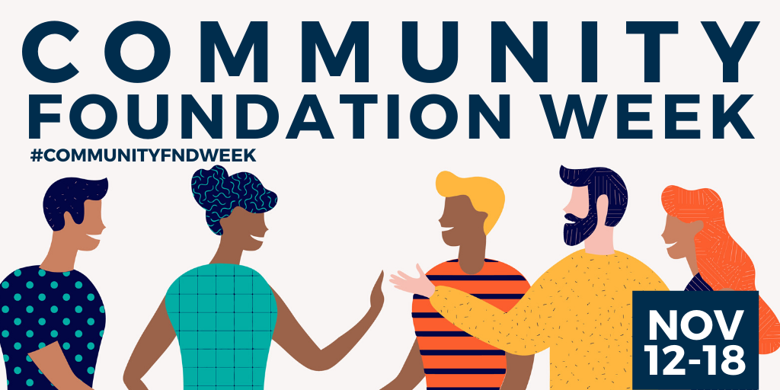

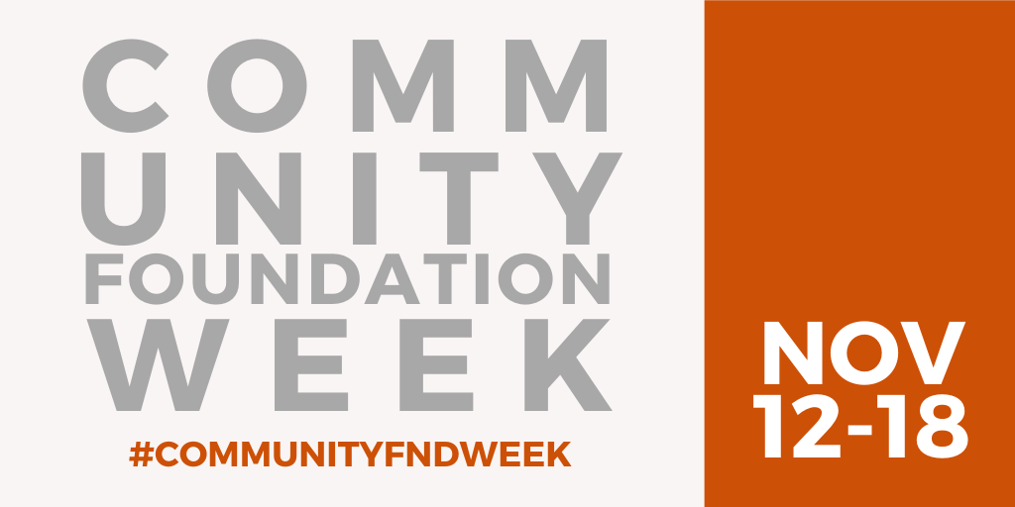
FACEBOOK/INSTAGRAM POST
